## **Calculator**

**Program Description:**

Create a program which can do mathematical operations. Insert two numbers into two different text boxes and then compute the answer into a label box made to look like a text box. All math operations should be command boxes. Clear output and quit command boxes should be included. Colors and pictures (graphics) are for the A.

**Rubric:**

**“B”**

- 5 functions

**“A”**

-8 functions

-graphics

**Sample output:**

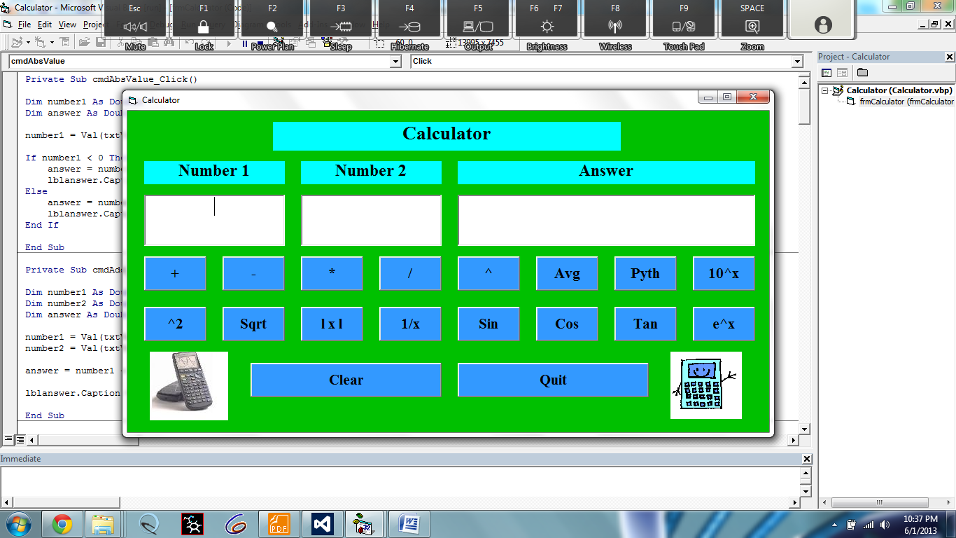

Example of gui needed for A++

**5 Standard Operations:**

Addition: 1+ (-1.5) = -.5

Subtraction: 1- 2 = -1

Multiplication: 1*-2 = -2

Division: 2/.5 = 4

Power: 2^(-2) = .25

**Possible Other Operations:** Average, Pythagorean, Log, Sin, Cos, Tan